Welcome to the Learning Center

From the Learning Center, you can access learning anytime, anywhere. You can monitor your personal progress and success that will help drive you toward your career aspirations.

GETTING STARTED
Access the Learning Center
From Internet Explorer, enter the following URL in your Internet browser:
Login  Enter your Login ID and Password. Click the Login button. Note: Both fields are case sensitive.  After logging in, the Portal Page will display. You may change your password by clicking on the My Profile link at the top right. | 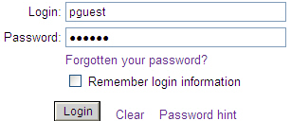
Main Portal Page  The Learning Center portal allows you to:  - View important Messages.  - Access Learning Resources and make use of several Quick Links.  - Perform a Search to locate information that you need.  - Access your personalized Learning Path, Online Courses, Instructor-Led Events, On-the-Job Activities and view your Current Status.  - Take a shortcut to any Pending Assignments.  Tip: The Learning Center uses pop-up windows in various places to display new information. If you encounter an error reading “Pop-up blocked,” you will need to change your computer setup to allow pop-ups. | 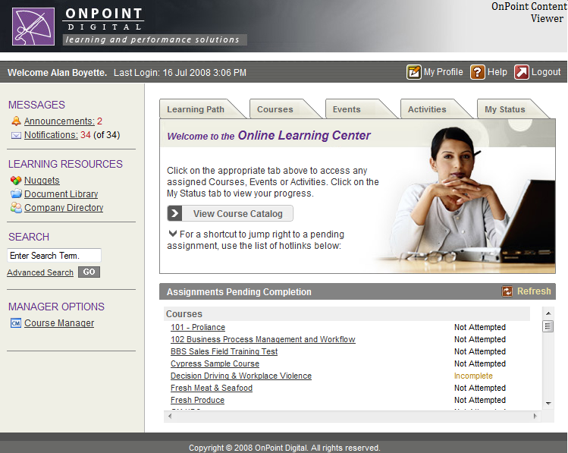
LEARNING CENTER ASSIGNMENTS AREA
Courses  Click the Courses tab to view any online learning courses you are currently assigned to complete. When you select a course, a Course Information Screen will appear providing more details.  Click Start to start a course. Click Continue to continue a course that you have previously started. Click Browse to revisit a course you have previously completed. If you did not pass a final test of a course, click the Retake button to begin the course again. | 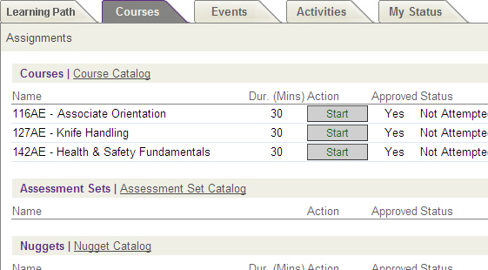
FINISH AND LOGOUT
Logout  When you are finished using any tabbed area of the Learning Center, click the Close icon to return to the main Portal page.  When you are finished using the Learning Center, click the Logout icon in the upper right corner. The system will ask if you are sure. Click the OK button to end your session. | 